# **Name: Abdurrahman Qureshi**

# **Roll No: 210451**

Practical No: 15

**1) Write a Program to create 2 buttons as “Simple Toast” and “Custom Toast” on click of Simple Toast button normal toast must be displayed and on click of Custom Toast button a message with an image must be displayed.**

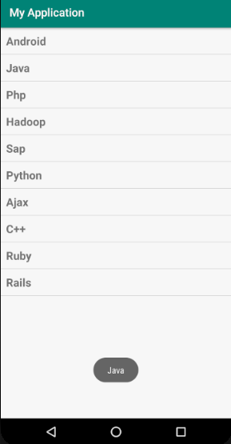

**XML Code:**

**activity_main.xml:**

<?xml version="1.0" encoding="utf-8"?>  
<LinearLayout xmlns:android="http://schemas.android.com/apk/res/android"  
 xmlns:app="http://schemas.android.com/apk/res-auto"  
 xmlns:tools="http://schemas.android.com/tools"  
 android:layout_width="match_parent"  
 android:layout_height="match_parent"  
 android:padding="10dp"  
 android:orientation="vertical"  
 android:gravity="center"  
 tools:context=".MainActivity">  
  
 <Button  
 android:id="@+id/simple_toast_button"  
 android:layout_width="wrap_content"  
 android:layout_height="wrap_content"  
 android:textSize="20sp"  
 android:padding="20dp"  
 android:text="Simple Toast"/>  
  
 <Button  
 android:id="@+id/custom_toast_button"  
 android:layout_width="wrap_content"  
 android:layout_height="wrap_content"  
 android:textSize="20sp"  
 android:padding="20dp"  
 android:text="Custom Toast"/>  
  
</LinearLayout>

**custom_toast.xml:**

<LinearLayout xmlns:android="http://schemas.android.com/apk/res/android"  
 android:id="@+id/custom_toast_layout"  
 android:layout_width="match_parent"  
 android:layout_height="match_parent"  
 android:orientation="vertical">  
  
 <ImageView  
 android:id="@+id/toast_image"  
 android:layout_width="wrap_content"  
 android:layout_height="wrap_content"  
 android:src="@drawable/ic_launcher_foreground"  
 android:background="@drawable/ic_launcher_background"/>  
  
 <TextView  
 android:id="@+id/toast_text"  
 android:layout_width="wrap_content"  
 android:layout_height="wrap_content"  
 android:textSize="20sp"/>  
  
</LinearLayout>

**Java Code:**

package com.example.madprac15;  
import androidx.appcompat.app.AppCompatActivity;  
import android.os.Bundle;  
import android.view.LayoutInflater;  
import android.view.View;  
import android.view.ViewGroup;  
import android.widget.Button;  
import android.widget.ImageView;  
import android.widget.TextView;  
import android.widget.Toast;  
public class MainActivity extends AppCompatActivity {  
 @Override  
 protected void onCreate(Bundle savedInstanceState) {  
 super.onCreate(savedInstanceState);  
 setContentView(R.layout.*activity_main*);  
 Button simpleToast = (Button) findViewById(R.id.*simple_toast_button*);  
 Button customToast = (Button) findViewById((R.id.*custom_toast_button*));  
 simpleToast.setOnClickListener(new View.OnClickListener() {  
 @Override  
 public void onClick(View view) {  
 Toast.*makeText*(getApplicationContext(), "This is a simple toast.", Toast.*LENGTH_SHORT*).show();  
 }  
 });  
 customToast.setOnClickListener(new View.OnClickListener() {  
 @Override  
 public void onClick(View view) {  
 LayoutInflater inflater = getLayoutInflater();  
 View layout = inflater.inflate(R.layout.*custom_toast*, (ViewGroup) findViewById(R.id.*custom_toast_layout*));  
 TextView toastText = (TextView) findViewById(R.id.*toast_text*);  
 toastText.setText("This is a custom toast");  
 Toast customToast = new Toast(getApplicationContext());  
 customToast.setDuration(Toast.*LENGTH_LONG*);  
 customToast.setView(layout);  
 customToast.show();  
 }  
 });  
 }  
}

**Output:**

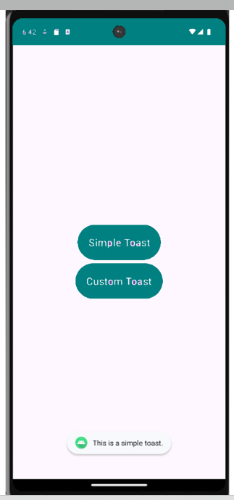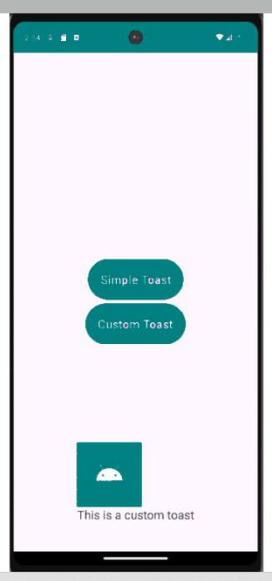

**2) Write a program to display three checkboxes and one button named “Order” as shown below. Once you click on button it should display simple toast along with items name and total price. Display custom toast on selection of checkbox.**

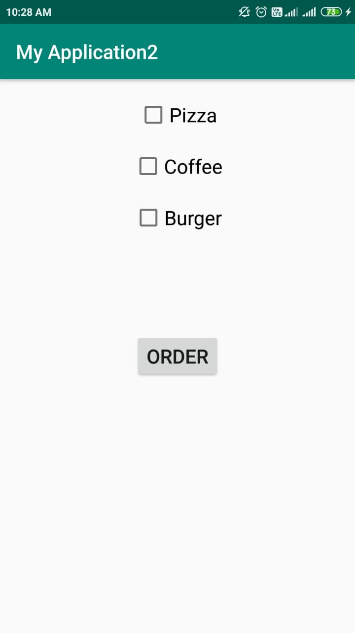

**XML Code:**

**activity_main.xml:**

<?xml version="1.0" encoding="utf-8"?>  
<LinearLayout xmlns:android="http://schemas.android.com/apk/res/android"  
 xmlns:app="http://schemas.android.com/apk/res-auto"  
 xmlns:tools="http://schemas.android.com/tools"  
 android:layout_width="match_parent"  
 android:layout_height="match_parent"  
 android:padding="10dp"  
 android:orientation="vertical"  
 android:gravity="center"  
 tools:context=".MainActivity">  
  
 <CheckBox  
 android:id="@+id/pizza_box"  
 android:layout_width="wrap_content"  
 android:layout_height="wrap_content"  
 android:text="Pizza"  
 android:onClick="showMessage"  
 android:textSize="30sp"/>  
  
 <CheckBox  
 android:id="@+id/coffee_box"  
 android:layout_width="wrap_content"  
 android:layout_height="wrap_content"  
 android:text="Coffee"  
 android:onClick="showMessage"  
 android:textSize="30sp"/>  
  
 <CheckBox  
 android:id="@+id/burger_box"  
 android:layout_width="wrap_content"  
 android:layout_height="wrap_content"  
 android:text="Burger"  
 android:onClick="showMessage"  
 android:textSize="30sp"/>  
  
 <Button  
 android:id="@+id/order_button"  
 android:layout_width="wrap_content"  
 android:layout_height="wrap_content"  
 android:text="Order"  
 android:textSize="30sp"  
 android:layout_marginTop="200dp"/>  
  
</LinearLayout>

**custom_toast.xml:**

<LinearLayout xmlns:android="http://schemas.android.com/apk/res/android"  
 android:id="@+id/custom_toast_layout"  
 android:layout_width="match_parent"  
 android:layout_height="match_parent"  
 android:orientation="vertical">  
  
 <ImageView  
 android:id="@+id/toast_image"  
 android:layout_width="wrap_content"  
 android:layout_height="wrap_content"  
 android:src="@drawable/ic_launcher_foreground"  
 android:background="@drawable/ic_launcher_background"/>  
  
 <TextView  
 android:id="@+id/toast_text"  
 android:layout_width="wrap_content"  
 android:layout_height="wrap_content"  
 android:textSize="20sp"/>  
  
</LinearLayout>

**Java Code:**

package com.example.madprac15;   
import androidx.appcompat.app.AppCompatActivity;   
import android.os.Bundle;  
import android.view.LayoutInflater;  
import android.view.View;  
import android.view.ViewGroup;  
import android.widget.Button;  
import android.widget.CheckBox;  
import android.widget.ImageView;  
import android.widget.TextView;  
import android.widget.Toast;

public class MainActivity extends AppCompatActivity {  
 @Override  
 protected void onCreate(Bundle savedInstanceState) {  
 super.onCreate(savedInstanceState);  
 setContentView(R.layout.*activity_main*);   
 Button orderButton = (Button) findViewById(R.id.*order_button*);  
 CheckBox pizzaCb = (CheckBox) findViewById(R.id.*pizza_box*);  
 CheckBox coffeeCb = (CheckBox) findViewById(R.id.*coffee_box*);  
 CheckBox burgerCb = (CheckBox) findViewById(R.id.*burger_box*);   
 orderButton.setOnClickListener(new View.OnClickListener() {  
 @Override  
 public void onClick(View view) {  
 String result = "You have ordered:\n";  
 int price = 0;  
 if(pizzaCb.isChecked() || burgerCb.isChecked() || coffeeCb.isChecked()) {  
 result += pizzaCb.isChecked() ? "Pizza\n" : "";  
 result += coffeeCb.isChecked() ? "Coffee\n" : "";  
 result += burgerCb.isChecked() ? "Burger\n" : "";  
 price += pizzaCb.isChecked() ? 100 : 0;  
 price += coffeeCb.isChecked() ? 45 : 0;  
 price += burgerCb.isChecked() ? 75 : 0;  
 result += "Total price: " + price;  
 } else {  
 result = "Nothing selected";  
 }  
 Toast.*makeText*(getApplicationContext(), result, Toast.*LENGTH_LONG*).show();  
 }  
 });  
 }  
 public void showMessage(View view) {  
 if(((CheckBox) view).isChecked()) {  
 LayoutInflater inflater = getLayoutInflater();  
 View layout = inflater.inflate(R.layout.*custom_toast*, (ViewGroup) findViewById(R.id.*custom_toast_layout*));  
 TextView toastText = layout.findViewById(R.id.*toast_text*);  
 toastText.setText(((CheckBox) view).getText().toString() + " selected.");   
 Toast toast = new Toast(getApplicationContext());  
 toast.setDuration(Toast.*LENGTH_LONG*);  
 toast.setView(layout);  
 toast.show();  
 }  
 }  
}

**Output:**

